7.1.1 Editors - 3D View - Tool Shelf - Object Mode
Detailed table of content 1
Tool Shelf - Object Mode 4
Select Tools Group 4
Cursor 6
Move 6
Rotate 8
Scale Tools Group 10
Transform 14
Annotate Tools group 15
Measure 17

Detailed table of content
Detailed table of content
Detailed table of content 1
Tool Shelf - Object Mode 4
Select Tools Group 4
Tweak 4
Select Box 4
Tool Settings 4
Mode 4
Set a new selection 5
Extend existing selection 5
Subtract existing selection 5
Inverts existing selection 5
Intersect existing selection 5
Select Circle 5
Tool Settings 5
Mode 5
Set a new selection 5
Extend existing selection 5
Subtract existing selection 5
Radius 5
Select Lasso 5
Tool Settings 5
Mode 5
Set a new selection 6
Extend existing selection 6
Subtract existing selection 6
Inverts existing selection 6
Intersect existing selection 6
Cursor 6
Tool Settings 6
Surface Project 6
Orientation 6
Move 6
Snapping 6
Precision movement 6
Header Values 6
Move without widget 7
Limit Axis 7
Tool Settings 7
Orientation 7
Last Operator Move 7
Move X, Y Z 7
Orientation 8
Proportional editing 8
Proportional Falloff 8
Proportional Size 8
Connected 8
Projected(2D) 8
Rotate 8
Snapping 8
Precision rotation 8
Header Values 8
Rotate without widget 9
Limit Axis 9
Tool Settings 9
Orientation 9
Last Operator Rotate 9
Angle 9
Axis 9
Orientation 10
Proportional editing 10
Proportional Falloff 10
Proportional Size 10
Connected 10
Projected(2D) 10
Scale Tools Group 10
Scale 10
Snapping 10
Precision Scale 10
Header Values 11
Scale without widget 11
Limit Axis 11
Tool Settings 11
Orientation 11
Last Operator Resize 11
Angle 11
Axis 11
Orientation 12
Proportional editing 12
Proportional Falloff 12
Proportional Size 12
Connected 12
Projected(2D) 12
Scale Cage 12
Snapping 12
Header Values 12
Scale without widget 13
Limit Axis 13
Tool Settings 13
Orientation 13
Last Operator Resize 13
Angle 13
Axis 13
Orientation 13
Proportional editing 14
Proportional Falloff 14
Proportional Size 14
Connected 14
Projected(2D) 14
Transform 14
Tool Settings 14
Drag Action 14
Orientation 14
Annotate Tools group 15
Annotate 15
Annotate Line 15
Annotate Polygon 15
Tool Settings 15
Color 15
Note 15
Annotations list 16
Edit Box 16
Fake User 16
Add Annotation 16
Unlink Annotation 16
Thickness 16
Frame Locked/Unlocked 16
Delete Active Frame 16
Thickness 16
Placement 16
Annotate Eraser 16
Tool Settings 16
Radius 16
Measure 17
Measuring angles 17
Snapping 17
Delete measure lines 17

Tool Shelf - Object Mode

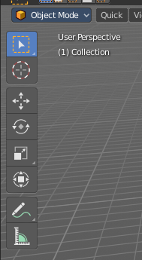
In Object mode you will see mainly the general select and transform tools.

Those tools will also appear in other modes like Edit mode. We will not cover it again there.

Select Tools Group
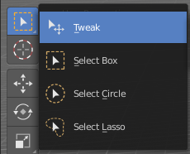
Tools with a triangle down right are a group of tools. Click and hold to reveal the content. Then choose the tool that you need.

Tweak
Allows you to select or tweak single elements by clicking at it.

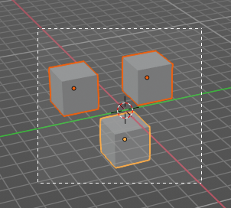
Select Box
Draws a box to select several elements at once. Click at the start point, then drag.

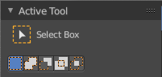
Tool Settings

Mode
The available selection modes. The mode titles are pretty self explaining. So i won't go into detail here.

Set a new selection

Extend existing selection

Subtract existing selection

Inverts existing selection

Intersect existing selection

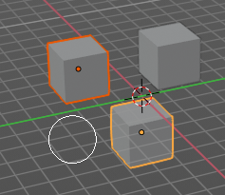
Select Circle
Draws a box to select several elements at once. Click at the start point, then drag.

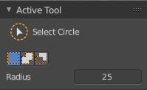
Tool Settings

Mode
The available selection modes. The mode titles are pretty self explaining. So i won't go into detail here.

Set a new selection

Extend existing selection

Subtract existing selection

Radius
The brush radius.

Select Lasso
Draws a box to select several elements at once. Click at the start point, then drag.

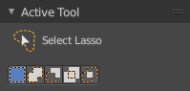
Tool Settings

Mode
The available selection modes. The mode titles are pretty self explaining. So i won't go into detail here.

Set a new selection

Extend existing selection

Subtract existing selection

Inverts existing selection

Intersect existing selection

Cursor
The cursor tool allows you to move the 3d cursor around.

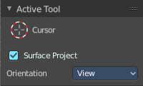
Tool Settings

Surface Project
Project the 3D cursor onto the surface.

Orientation
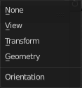
The 3d cursor can have different orientations. The menu items should be self explaining.

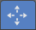
Move
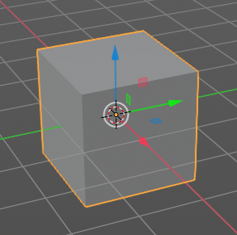
Activates the move tool. Activating the move tool also reveals a move widget at the object. This widget allows you to move the object around, by using the corresponding axis.
When you click at one of the square buttons at the icon, then you can move the object along the plane of the two adjacent axis. The rectangle buttons between the arrows allows you to move in direction of the blue and green arrows. This can also be done by clicking at the tip of the arrow and holding down shift. Then you can move the cube along the two other axis.

Snapping
Holding down Ctrl activates temporary global snapping.

Precision movement
When you hold down shift, then you will have a much slower but also much preciser movement.

Header Values
When you move your object then you will see some values in the header, which defines the current position of the object.
The value m stands for the default metric system. Meters. You can change the units in the Properties editor in the Scene properties in the Units panel. When you choose kilometers here then you will see a km instead m.
The value D stands for the distance of the current selected axis. This can also be two axis. Then you have two d values. The value in the brackets is then the direct distance to the starting point.
These values are always relative to the starting point. You always start with zero, regardless of the real world position.

Move without widget
You don't have to use the widget to move the object. You can also click aside of it, and drag the object around. The mouse turns into a move cursor. The standard behaviour then is to move in screen space. When you want to move into a specific axis, then press X or Y or Z to limit the movement to this axis.

Limit Axis
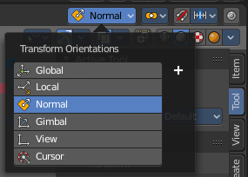
When you want to rotate a specific axis, then press X or Y or Z to limit the rotation to this axis. You usually start in global orientation. But you can change this in the Orientation settings.
By holding down the mouse button and pressing the X, Y or Z key twice you can toggle this to local. But also to other orientations. This depends in what orientation you start. With normal you can toggle that way between Normal and

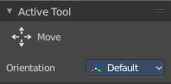
Tool Settings

Orientation

The widget can have different orientations. The menu items should be self explaining.

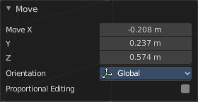
Last Operator Move

Move X, Y Z
The position. Attention, the actual world orientation and rotation does not matter here. It always starts with a value of zero, and moves relative to this zero then. For the actual location values have a look in the sidebar in the transform panel.

Orientation
The widget can have different orientations. The menu items should be self explaining.


Proportional editing
Enables proportional editing. Activating proportional editing reveals further settings.

Proportional Falloff
Here you can adjust the falloff methods.

Proportional Size
Here you can see and adjust the falloff radius.

Connected
The proportional falloff gets calculated for connected parts only.

Projected(2D)
The proportional falloff gets calculated in the screen space. Depth doesn't play a role. When it's in the radius, then it gets calculated.

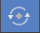
Rotate
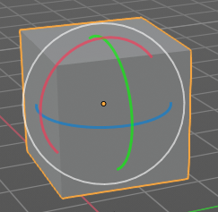
Activates the Rotate tool. Activating the move tool also reveals a rotate widget at the object. This widget allows you to rotate the object, by using the corresponding axis.

Snapping
Holding down Ctrl activates temporary global snapping.

Precision rotation
When you hold down shift, then you will have a much slower but also much preciser rotation.

Header Values
When you rotate your object then you will see some values in the header, which defines the current rotation of the object. The rotation is shown in degrees.

Rotate without widget
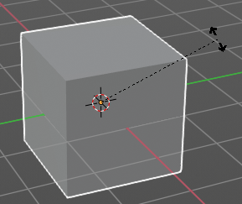
You don't have to use the widget to rotate the object. You can also click asides and drag the object around. A black arrow will appear. The standard behaviour then is to rotate in viewport orientation.

Limit Axis
When you want to rotate a specific axis, then press X or Y or Z to limit the rotation to this axis. You usually start in global orientation. But you can change this in the Orientation settings.
By holding down the mouse button and pressing the X, Y or Z key twice you can toggle this to local. But also to other orientations. This depends in what orientation you start. With normal you can toggle that way between Normal and Global.

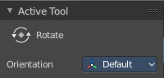
Tool Settings

Orientation
The 3d cursor can have different orientations. The menu items should be self explaining.

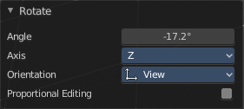
Last Operator Rotate

Angle
The rotation. Attention, the actual world orientation and rotation does not matter here. It always starts with a value of zero, and rotates relative to this zero then. For the actual rotation values have a look in the sidebar in the transform panel.

Axis
Which axis to rotate.

Orientation
The widget can have different orientations. The menu items should be self explaining.

Proportional editing
Enables proportional editing. Activating proportional editing reveals further settings.

Proportional Falloff
Here you can adjust the falloff methods.

Proportional Size
Here you can see and adjust the falloff radius.

Connected
The proportional falloff gets calculated for connected parts only.

Projected(2D)
The proportional falloff gets calculated in the screen space. Depth doesn't play a role. When it's in the radius, then it gets calculated.

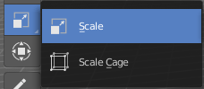
Scale Tools Group
You can use two scale tools with different widget styles.

Scale
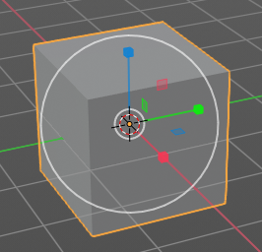
Activates the Scale tool. Activating the scale tool also reveals a traditional scale widget at the object. This widget allows you to scale the object, by using the corresponding axis. When you click at the outer white circle and drag, then you can scale the object uniformly.
The rectangle buttons between the arrows allows you to scale in direction of the adjacent arrows. This can also be done by clicking at the tip of the arrow and holding down shift. Then you can scale the cube along the two other axis.

Snapping
Holding down Ctrl activates temporary global snapping.

Precision Scale
When you hold down shift, then you will have a much slower but also much preciser scale.

Header Values
When you scale your object then you will see some values in the header, which defines the current scale of the object.
These values are always relative to the starting point. You always start with 1, regardless of the real world scale.

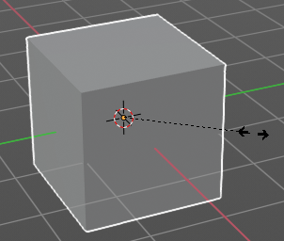
Scale without widget
You don't have to use the widget to scale the object. You can also click asides and drag the object around. A black arrow will appear. The standard behaviour then is to scale uniformly. When you want to scale into a specific axis, then press X or Y or Z to limit the scale to this axis.

Limit Axis
When you want to rotate a specific axis, then press X or Y or Z to limit the scale to this axis. You usually start in global orientation. But you can change this in the Orientation settings.
By holding down the mouse button and pressing the X, Y or Z key twice you can toggle this to local. But also to other orientations. This depends in what orientation you start. With normal you can toggle that way between Normal and Global.

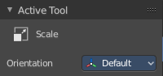
Tool Settings

Orientation
The 3d cursor can have different orientations. The menu items should be self explaining.

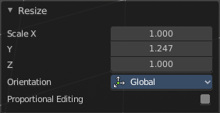
Last Operator Resize

Angle
The rotation. Attention, the actual world orientation and rotation does not matter here. It always starts with a value of zero, and rotates relative to this zero then. For the actual rotation values have a look in the sidebar in the transform panel.

Axis
Which axis to rotate.

Orientation
The widget can have different orientations. The menu items should be self explaining.

Proportional editing
Enables proportional editing. Activating proportional editing reveals further settings.

Proportional Falloff
Here you can adjust the falloff methods.

Proportional Size
Here you can see and adjust the falloff radius.

Connected
The proportional falloff gets calculated for connected parts only.

Projected(2D)
The proportional falloff gets calculated in the screen space. Depth doesn't play a role. When it's in the radius, then it gets calculated.

Scale Cage
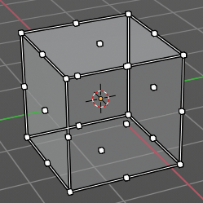
Activates the Scale tool. Activating the scale tool also reveals a scale widget in cage style at the object. This widget allows you to scale the object by clicking at the white handler points and drag them in the desired direction.

Snapping
Holding down Ctrl activates temporary global snapping.

Header Values
When you scale your object then you will see some values in the header, which defines the current scale of the object.
These values are always relative to the starting point. You always start with 1, regardless of the real world scale.

Scale without widget
You don't have to use the widget to scale the object. You can also click asides and drag the object around. A black arrow will appear. The standard behaviour then is to scale uniformly. When you want to scale into a specific axis, then press X or Y or Z to limit the scale to this axis.

Limit Axis
When you want to rotate a specific axis, then press X or Y or Z to limit the rotation to this axis. You usually start in global orientation. But you can change this in the Orientation settings.
By holding down the mouse button and pressing the X, Y or Z key twice you can toggle this to local. But also to other orientations. This depends in what orientation you start. With normal you can toggle that way between Normal and Global.

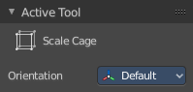
Tool Settings

Orientation
The 3d cursor can have different orientations. The menu items should be self explaining.

Last Operator Resize

Angle
The rotation. Attention, the actual world orientation and rotation does not matter here. It always starts with a value of zero, and rotates relative to this zero then. For the actual rotation values have a look in the sidebar in the transform panel.

Axis
Which axis to rotate.

Orientation
The widget can have different orientations. The menu items should be self explaining.

Proportional editing
Enables proportional editing. Activating proportional editing reveals further settings.

Proportional Falloff
Here you can adjust the falloff methods.

Proportional Size
Here you can see and adjust the falloff radius.

Connected
The proportional falloff gets calculated for connected parts only.

Projected(2D)
The proportional falloff gets calculated in the screen space. Depth doesn't play a role. When it's in the radius, then it gets calculated.

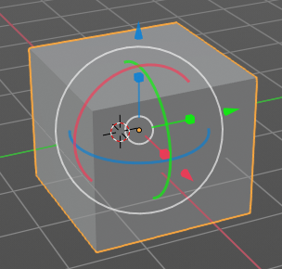
Transform
Transform reveals a multi transform widget with all three transform methods available at once. Move, Rotate and Scale.
The rules are the same than for the single tools, and also the last operators. Dependant of which widget part you pull here. So i won't go into detail again here.

Tool Settings

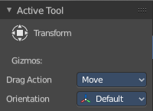
Drag Action
Here you can define what kind of transform should happen when you click not at the widget but besides, and drag the mouse.

Orientation
The 3d cursor can have different orientations. The menu items should be self explaining.

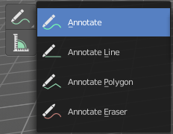
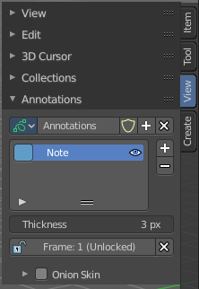
Annotate Tools group
The annotation tool is available in multiple editors. With this tool you can write notes at the screen. The annotate tools is the little brother of the grease pencil objects.
Further settings for annotate can be found in the sidebar. Here you can also remove an annotation when you don't longer need it. And here you can also adjust the size of the stroke.
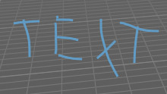

Annotate
Draw free-hand strokes in the main window.

Annotate Line
Click and drag to create a line.

Annotate Polygon
Click multiple times to create multiple connected lines. The current polygon is finished when Esc or RMB is pressed.

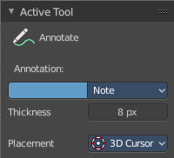
Tool Settings
The tool settings for Annotate, Annotate Line and Annotate Polygon are the same.

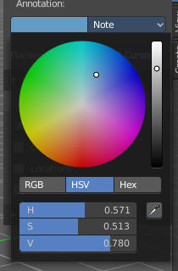
Color
Clicking at the left color field reveals a color picker where you can define the color for the annotation stroke.

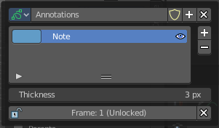
Note
Clicking at the Note dropdown box reveals a panel with further settings. It's the same content than in the annotations in the View tab.

Annotations list

Here you can add, remove and rename new annotations.

Edit Box
The name of the current annotation. You can rename the annotation to your needs here.

Fake User
Assign a fake user to this annotation. Fake users is a odd concept to keep data in the scene even if it has no user somewhere. The fake user is then a dummy user so that the object is not deleted when saving the scene.

Add Annotation
Add a new annotation.

Unlink Annotation
Delete the annotation.

Thickness
The thickness of the annotation stroke.

Frame Locked/Unlocked
Lock frame displayed by current layer. This toggles whether the active layer is the only one that can be edited.

Delete Active Frame
Deletes the active frame from the active grease pencil layer.

Thickness
The thickness of the annotation stroke.

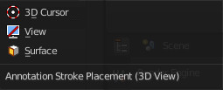
Placement
Here you can define how annotation strokes are aligned in the 3d space.

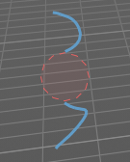
Annotate Eraser
Click and drag to remove annotate lines.

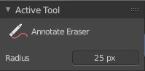
Tool Settings

Radius
The radius of the eraser pencil.

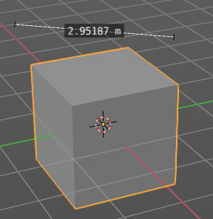
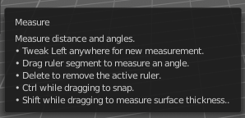
Measure
Allows you to draw measure lines into the view.
The measure tool has a few options, which are described in the tooltip.
New measure lines gets created by left clicking and dragging.
When you change the tool then the measure lines becomes visible. But they are not removed. When you activate the measure tool then they reappear.

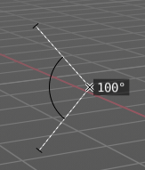
Measuring angles
When you want to measure an angle, first create a straight measure line. Then grab it in the middle to drag out a new point at the line. Then align everything proper.

Snapping
Holding down Ctrl activates temporary global snapping.

Delete measure lines
Select them and press delete. When you have selected an angle point then first this angle point gets deleted. You need to have to select a endpoint to make the whole stroke active.

